Rotary Club of Kathmandu Mid-Town
Breakfast Chatter




30 March 2012 The Weekly Bulletin of Rotary Club of Kathmandu Mid-Town Bc-3.30/011-12

District: 3292 Web: www.rotarymidtown.org.np Club Id : 26776

MARCH IS LITERACY MONTH
Teach children the value of life, and that they should respect others, no matter what sex or caste they belong to. If you can change their way of thinking, and introduce them to a better way of life,
you will be doing them and the entire community a great service.

23 March, Friday
Ms Fionna Heiton together with Mr Durga Aran gave a presentation on ‘First Steps HIMALAYA - giving children a childhood’. This organization was founded in 2008, they started early childhood centre in 2009 in Sangachowk, Sindhupalchowk. Now they have 11 early childhood centers and have just created a new class 1 in Village School. Their vision is to be a key provider of quality education in partnership with rural communities. They emphasized on play-based learning and child friendly teaching in schools. Currently there are 300 children and 30 local staffs in early childhood centers. They run free pre-school classes and have established community library services. Besides imparting basic education to children, they have trained teachers, conducted programs for improving health and hygiene condition of locals. They raise funds to support the project. They are interested to work together with Rotary Clubs for fund-raising.
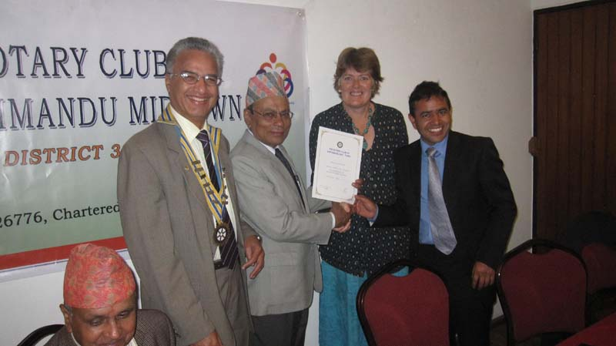
DGE Yogendra handing over certificate of appreciation to GS Fionna and Durga
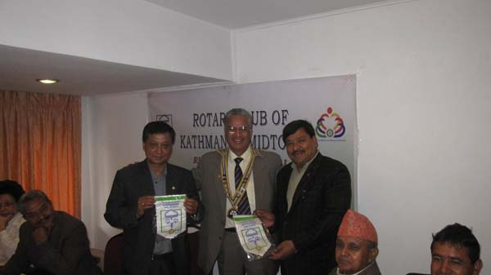
President Som presenting Midtown banner to Rtn Rajendra Dhoju, President RC Butwal
and to PP Kiran Shrestha, Pokhara

Weekly Meetings and Programs :
Date | Program/Speaker | Program/Topics of Presentation
30 March 2012 | Archana Thapa | Alternative History: Women's Personal Stories
6 April 2012 | CP Roop Jyoti | Why Vipassana Meditation?

India is no longer polio endemic:
The World Health Organization has officially removed India from the list of polio-endemic countries. Ghulam Nabi Azad, India's minister of Health and Family Welfare, made the announcement at the Polio Summit 2012 in New Delhi on 25 February. Azad said that he had been informed of WHO’s action by its director-general, Dr. Margaret Chan.
"It is a matter of satisfaction that we have completed one year without any single new case of polio being reported from anywhere in the country," said Indian Prime Minister Manmohan Singh at the summit, which was organized by the government of India and Rotary International. "This gives us hope that we can finally eradicate polio not only from India but from the face of the entire mother earth. The success of our efforts shows that teamwork pays." India's last reported case was a two-year-old girl in West Bengal State on 13 January 2011. Before polio eradication can be certified in India, it must go two more years without another case of the disease. Polio remains endemic in only three countries: Afghanistan, Nigeria, and Pakistan.
Bivalent oral vaccine
Until 2009, India accounted for nearly half the number of the world’s polio cases. A chief factor in the country’s success has been the widespread use of the bivalent oral polio vaccine, which is effective against both remaining types of the poliovirus. Another has been rigorous monitoring, which has helped reduce the number of children missed by health workers during National Immunization Days to less than 1 percent, according to WHO.
Rotary International has played a major role in helping to stop the transmission of polio in India. Rotary has been a spearheading partner in the Global Polio Eradication Initiative since 1988, along with WHO, UNICEF, and the U.S. Centers for Disease Control and Prevention. The Bill & Melinda Gates Foundation is also a key supporter of the initiative.
Sporting their signature yellow vests and caps, the nearly 119,000 Rotarians in India have helped administer vaccine to children, organize free health camps and polio awareness rallies, and distribute banners, caps, comic books, and other items. (To be cont’d)
Source: Dan Nixon/Rotary International News

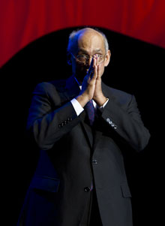
If we wish for peace, we start by living in peace ourselves, in our homes and in our
communities. If we wish environmental degradation to stop, if we wish to reduce child mortality
or to prevent hunger, we must be the instrument of that change — and recognize that it must
start within us, with each of us.
RI President Kalyan Banerjee

On Lighter Side : Click here ⇩


A thought for the day:
When you are in the light, everything follows you,
but when you enter into the dark, even your own shadow doesn't follow you.
- Adolf Hitler

Bokas of ANFA:
The Nepali football officials offered a fat black he-goat to the deity of Dakshinkali just ahead of the start of the AFC Challenge Cup held in Kathmandu, wishing for a resounding success of the Nepali team in the Cup. It seems that the deity of power is not happy with the football officials, which is reflected in the abject failure of their team in the Cup. Boka as a word in Nepali is a term used to make fun of a witless person. After the repeated failures of the Nepali soccer team, the act of sacrificing the hapless animal has rendered all the football officials true bokas themselves. They are witless to the extent that they have no idea about the real capability of their present team, which failed to score a single goal in three matches in the Cup. Had the offering of a black he-goat to the deities brought successes, all the Nepali sports teams would have been world champions!!
Source: NU/The Rising Nepal


Nature and photography: water drops

Please send project/activity information, suggestions and photos etc to :
BC Editor: RR Shrestha email: rryes@wlink.com.np

30 March 2012 The Weekly Bulletin of Rotary Club of Kathmandu Mid-Town bc-3.30/011-12

